Project Apollo

DIY oxygen concentrator project

**Author**: Adi Oltean, Jack Gallagher

# Goal

Build a reasonable DIY oxygen concentrator for less than $100.

# Justification

* We need to come up with an early design fast. It is becoming increasingly clear that access to oxygen-rich air is critical to many medical facilities across the globe given that we are running out of beds in many affected areas by COVID-19 [[1](https://www.usatoday.com/in-depth/news/investigations/2020/03/13/us-hospitals-overwhlemed-coronavirus-cases-result-in-too-few-beds/5002942002/)], [[2](https://www.brusselstimes.com/all-news/belgium-all-news/health/99412/coronavirus-we-must-choose-who-to-treat-says-italian-doctor-covid-19-christian-salaroli/)]
* The inspiration for the project name came from the Apollo 13 movie, the oxygen scene: <https://www.youtube.com/watch?v=1cYzkyXp0jg>
* Additionally, according to the interviewed Seattle doc, ⅔ of hospitalized patients didn’t require much more care than o2 therapy, so any way to rapidly scale out concentrator production can probably take a large load off of hospitals.

# Requirements

* Long-running (>1.5 years). Dependable.
* Super-simple design. Eliminate anything not strictly needed in the initial prototype.
  + Example: No built-in compressor. Instead it should work with a variety of external compressors, some which can generate impurities such as oil mist or water vapors (common problems with all compressors)
* Should be buildable from household materials (except zeolites which can be acquired inexpensively over the internet).
* Total cost under $100.
* Built-in air filter and drier.
* Easy to maintain: easy to tear down, fix and replace drying silica beads or zeolite beads
* Relatively leak-free. Easy to build by a novice/inexperienced person
* Should not require calibration or complex sensors.

# Deadlines

* Project start date: March 12nd 2020
* Plan to build first prototype by March 15th 2020 (assuming critical parts arrive in time)
* Community feedback in the week of March 16th .. March 22nd
* Publish schematics/instructions: March 23rd
* Publish educational videos: April 1st

To achieve these tight deadlines I will mainly order parts over Amazon Prime for the initial prototype. I expect that subsequent iterations could be much cheaper if we select other vendors (ebay/aliexpress)

# Plan

* Tear down existing oxygen concentrator, produce schematics
  + Started with an Invacare PlatinumXL, will also tear down a [Philips Respironics Everflo](https://www.philips.it/healthcare/product/HC1020000/everflo-sistema-per-ossigenoterapia-domiciliare/specifiche)
  + Some early high-level schematics already available (see Google Docs)
* Find out and select all critical parts for the design.
  + Critical parts such as 4-way valve should be available cheaply online (about $8 on aliexpress). One can also use sequences of 3-way valves to reduce price even further.
* Try and test various building techniques
  + Use either PVC piping (glued using PVC cement) or even inexpensive Coca-Cola plastic bottles (with Schrader tire valves) to host the zeolite beads
    - PVC piping is known to work very reliably. PVC cement can offer strong seals that resist pressure but it’s more expensive
    - Coca-Cola plastic work as well but they require care in sealing all connectors. One needs to use Schrader valves with a solid steel screw (not a rubber-only tire valve). This method is very inexpensive and also allows visual inspection of the inner tank.
  + Devise easy-to-follow leak-proof methods of hooking up ¼ NPT fittings to bottles/tubing
* Define O2 concentration testing procedures and equipment
  + This is only needed initially (or during maintenance) to ensure that proper O2 concentration is achieved.
  + What methods do we have to test fast the O2 concentration? (to verify that it’s working). This is needed both during prototype building and for actual people to test effectiveness in the field
  + We should use inexpensive, off-the-shelf O2 sensors
    - One approach is to use sensors that go up to 100% O2 range (<https://ebay.to/2w0l03V>)
    - Another good sensor is AlphaSense <https://ebay.to/2voJHXn>
    - A third approach is to measure ultrasonic speed in gas, which can be then used to infer O2 concentration
  + A very low-tech (but slow and inaccurate) way of measuring oxygen levels is to oxidize steel wool in an air pocket in water (i.e. cup under water); the rising water level will indicate oxygen ratio.
  + Alternate method to measure oxygen would be to use a large syringe with a concentrated alkaline sulfite solution (a mixture of sodium carbonate and sodium sulfite). The process is as follows
    - Empty syringe
    - Load a certain quantity of oxygen gas (say 5 cc) at atmospheric pressure
    - Load the rest of syringe with sulfite solution (almost full but not completely)
    - Seal the syringe with a cap
    - Shake the syringe, let O2 react (time needed TBD). May need to push the piston as O2 gets absorbed and volume decreases
    - Remove the cap with the syringe tip in the sulfite solution. This will bring back the internal pressure to atmospheric pressure
    - Measure the CC of the left-over gas.
* Put everything together
* Publish schematics/assembly instructions (instructables.com)
* Create educational videos (Youtube.com)

# Design

The design largely follows the Invacare UltimateXL concentrator

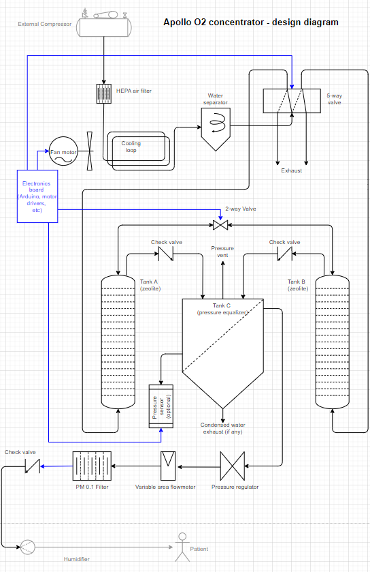

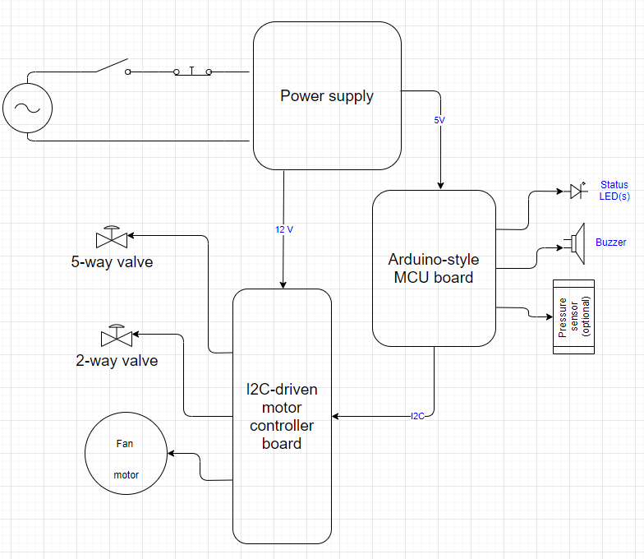

<https://app.diagrams.net/#G1kPbCl5ovqBm8P-cGXHFyqWj3fPpxTx9a>

# Design Details

(TODO - need to fill them out)

# References

* Design diagram (mechanical and electrical) <https://app.diagrams.net/#G1kPbCl5ovqBm8P-cGXHFyqWj3fPpxTx9a>
* Materials used in this project: <https://docs.google.com/spreadsheets/d/1z2IGBbogw0IXtrmvrYVPU0OdOPh84csYU2X4E59rGJ4/edit#gid=0>
* Invacare PlastinumXL teardown: <https://app.diagrams.net/#G1j7rN7OEIzGBMiwEABOPO_E3F8IdTulai>
* Other files: <https://drive.google.com/drive/u/0/folders/1IS1OyGSm_M9yfGUIV-yd1-hIz1FD5UvA>